MYSQL -1
ASSIGNMENT -1
DDL COMMANDS AND CONSTRAINTS
-
DDL Commands :
--1. Table Creation (CREATE): Write the SQL statements to create a database named
--“employee” and the following tables based on the provided schema:
--⦿ Departments
--⦿ Location
--⦿ Employees
CREATE DATABASE EMPLOYEE
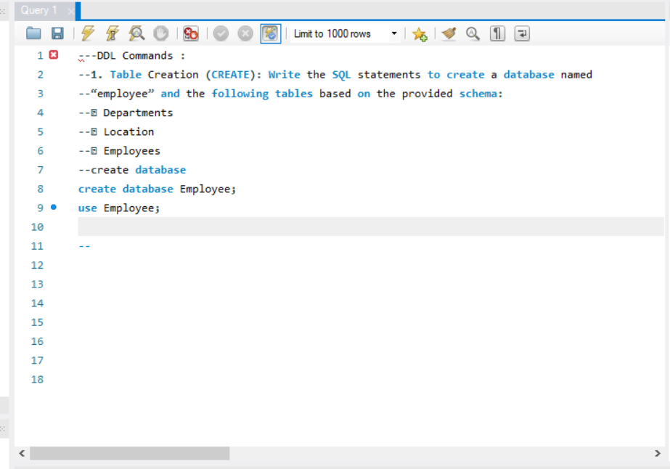
CREATE DEPARTMENT TABLE
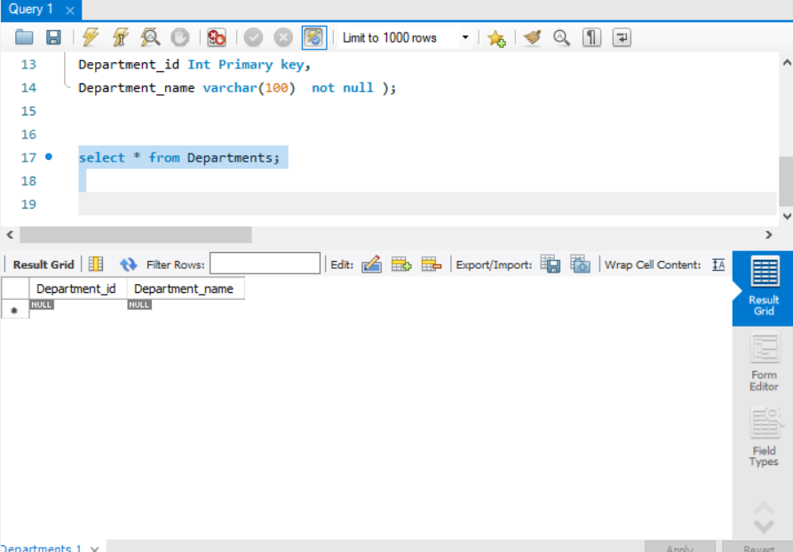
CREATE LOCATION TABLE
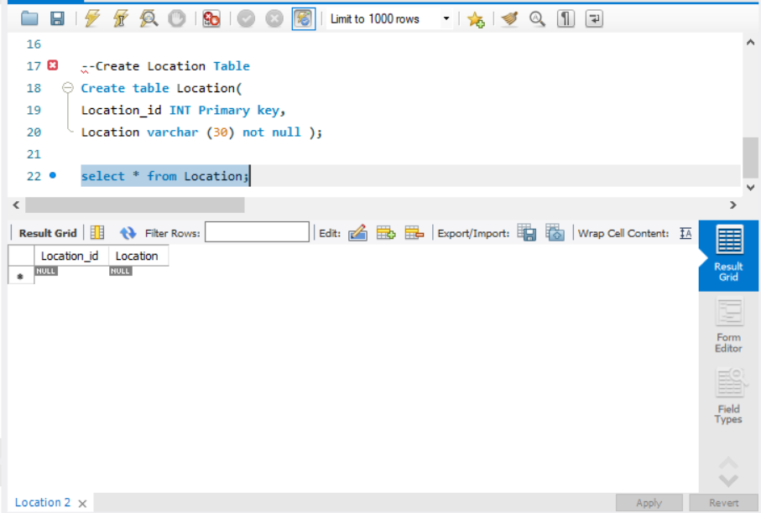
CREATE EMPLOYEES TABLE
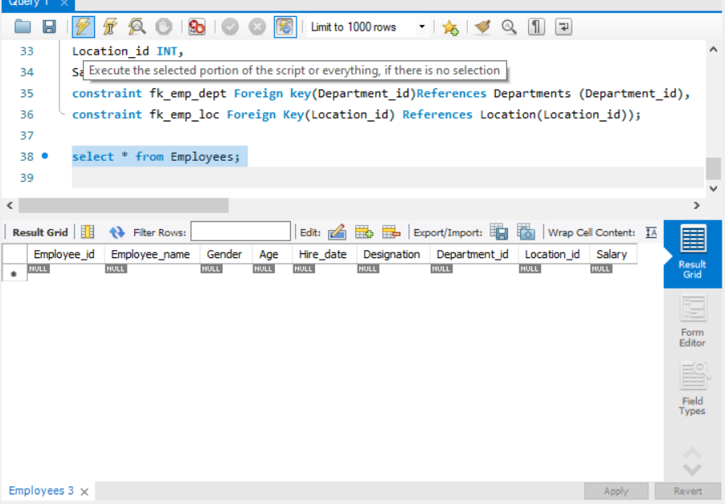
2. Table Alteration (ALTER): Consider the following scenarios and write the SQL
statements to alter the structure of the tables accordingly:
⦿ Add a new column named "email" to the Employees table to s tore employee email addresses.
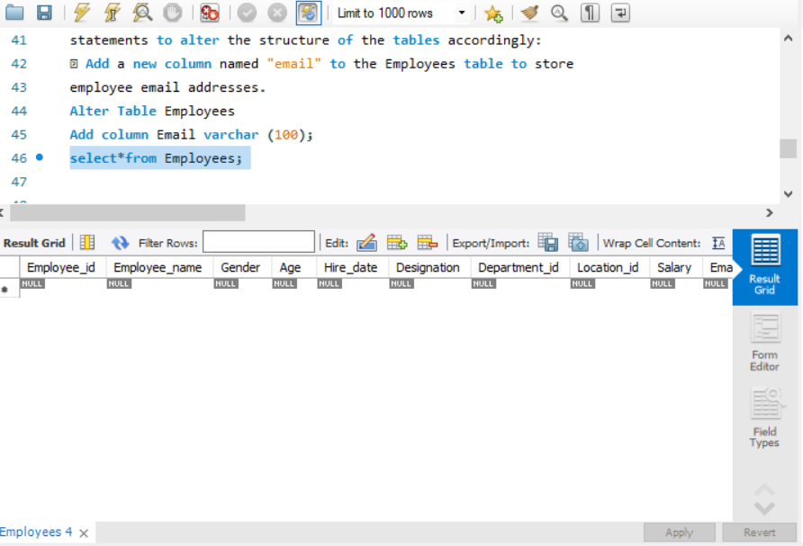

⦿ Modify the data type of the "designation" column in the Employees table to support a wider range of values.

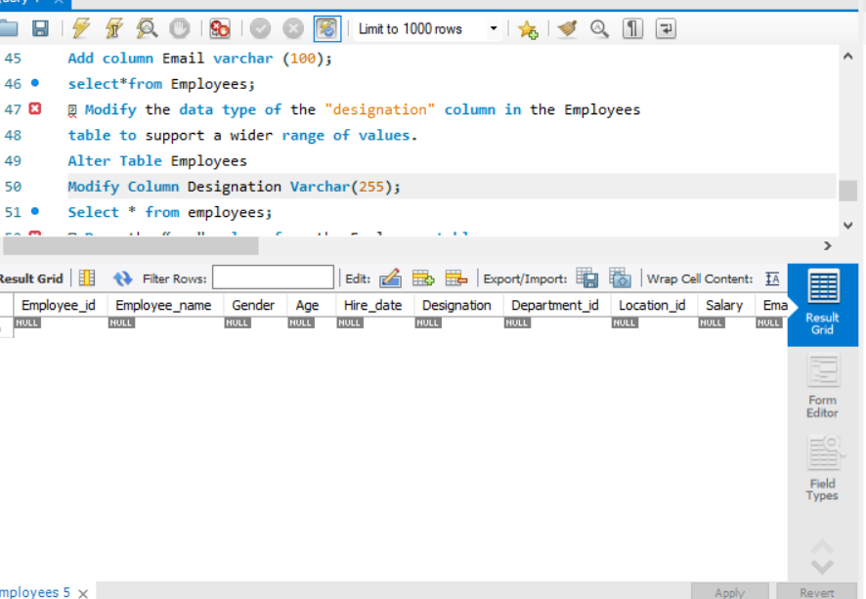

⦿ Drop the “age” column from the Employees table.
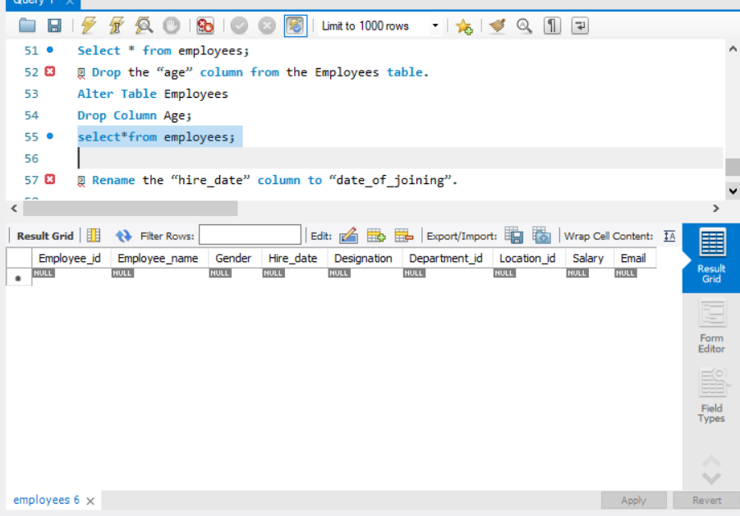

⦿ Rename the “hire_date” column to “date_of_joining”.

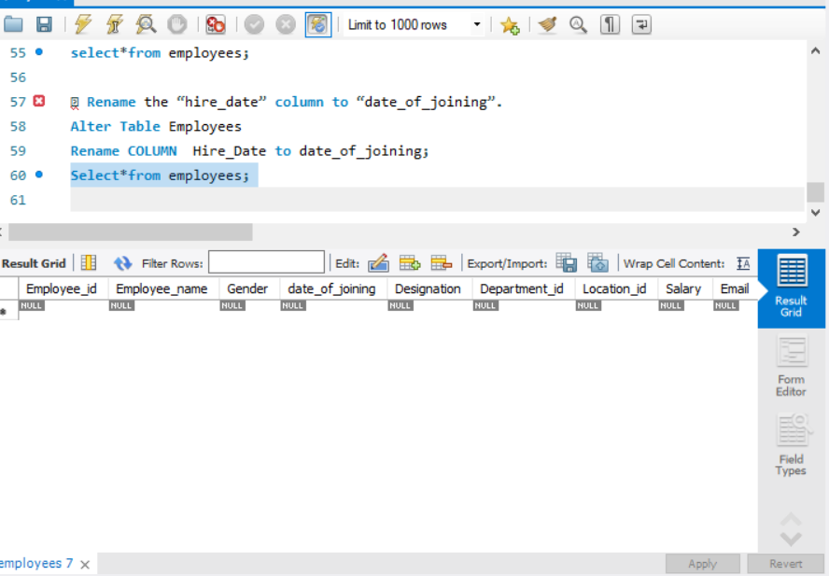

3. Table Renaming (RENAME): Rewrite the SQL statements to rename the
following tables:
⦿ Rename the "Departments" table to "Departments_Info".

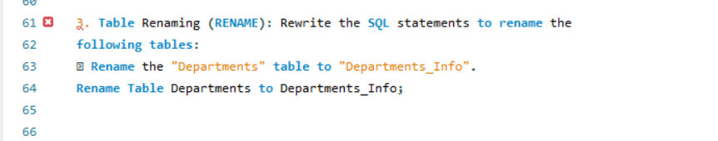

⦿ Rename the "Location" table to "Locations".
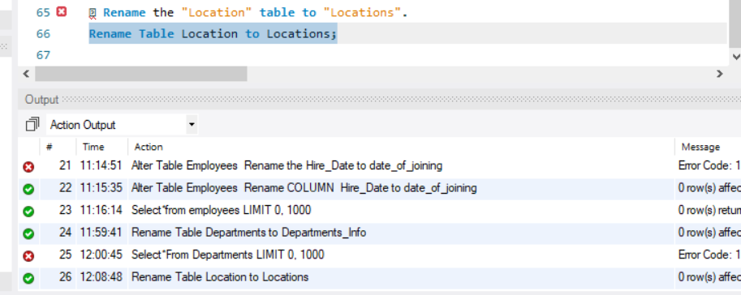

4. Table Truncation (TRUNCATE): Write an SQL statement to truncate the Employees table.
--Truncate the Employees Table ( delete all rows,keep structure)
Truncate Table Employees; 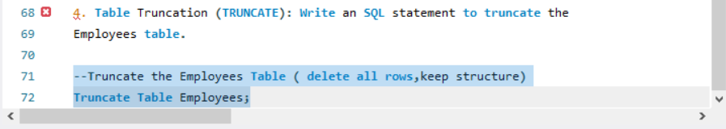

5. Database & Table Dropping (DROP): Write the SQL statements to drop the
Employees table and then the “employee” database.

--Drop Employees table
USE Employee;
Drop Table Employees;

--DROP THE EMPLOYEE DATABASE
DROP DATABASE Employee;
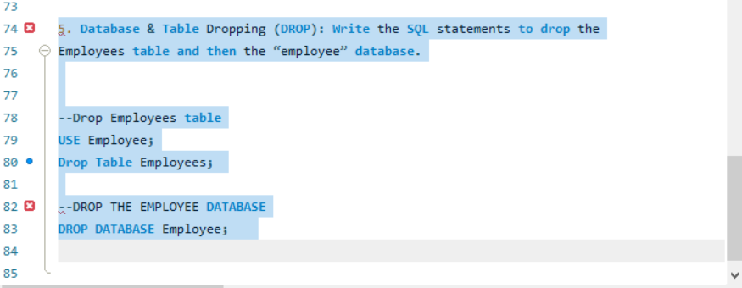

CONSTRAINTS

1. Database Recreation:

⦿ Drop the 'employee' database if it exists and recreate it using the
provided schema, ensuring that all tables are created with the
appropriate constraints as instructed.

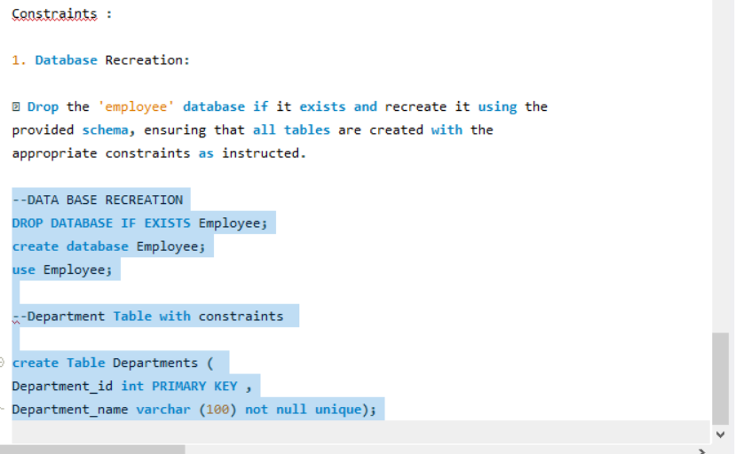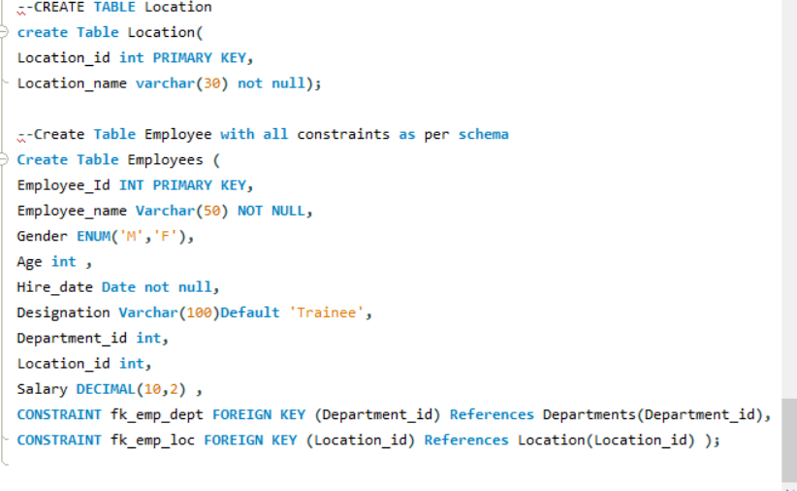
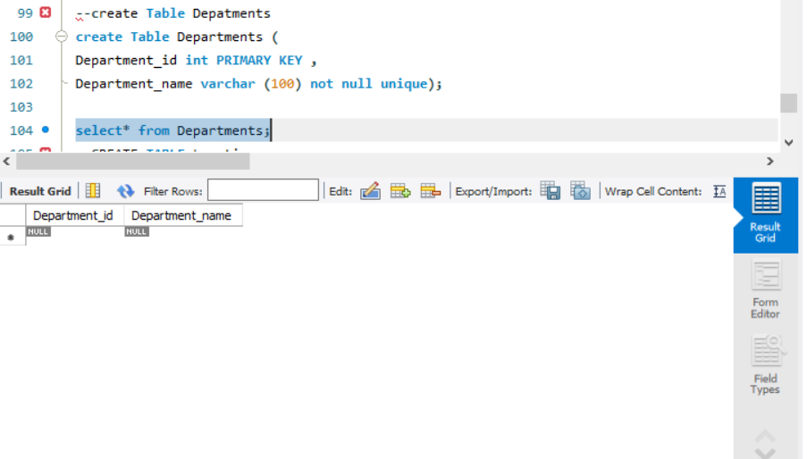

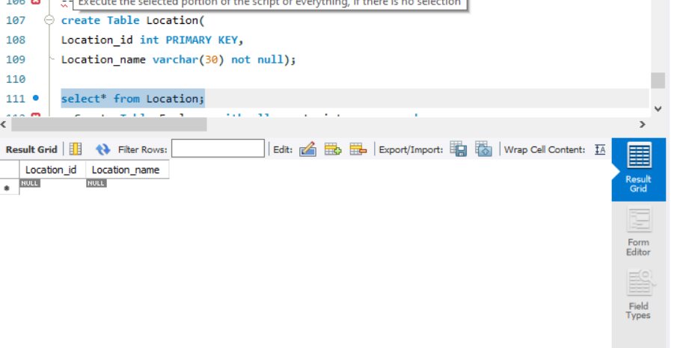
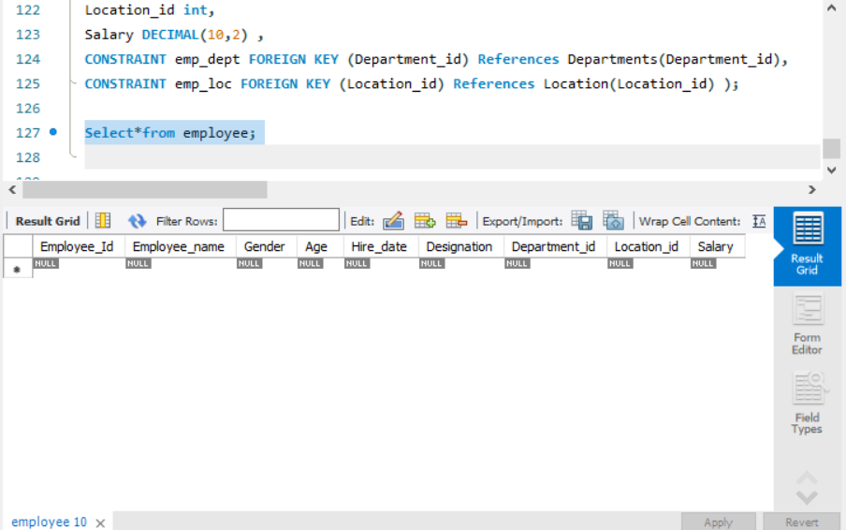

2. Departments Table:

⦿ Ensure that the "department_id" uniquely identifies each department.
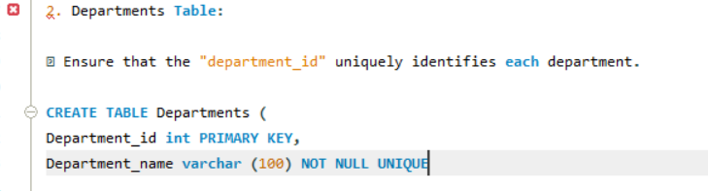 -- Primary Key on Department_id =it will be UNIQUE +NOT NULL automatically,
so no two departments can have same id .It uniquely identifies each row

⦿ Set up constraints on the "department_name" to avoid duplicate and null
entries.
